**MEASURING THE PULSE OF PROSPERITY: AN INDEX OF ECONOMIC FREEDOM ANALYSIS**

**1.INTRODUCTION**

**1.1 OVER VIEW**

Economic freedom is the fundamental right of every human to control his or her own labor and property. In an economically free society, individuals are free to work, produce, consume, and invest in any way they please. In economically free societies, governments allow labor, capital, and goods to move freely, and refrain from coercion or constraint of liberty beyond the extent necessary to protect and maintain liberty itself.

Most individuals have lacked economic freedom and opportunity, condemning them to poverty and deprivation. Today, we live in the most prosperous time in human history. Poverty, sicknesses, and ignorance are receding throughout the world, due in large part to the advance of economic freedom.

**1.2 PURPOSE**

The Heritage Foundation website states that "Economic freedom is the fundamental right of every human to control his or her own labor and property. In an economically free society, individuals are free to work, produce, consume, and invest in any way they please. In economically free societies, governments allow labor, capital, and goods to move freely, and refrain from coercion or constraint of liberty beyond the extent necessary to protect and maintain liberty itself." By publishing yearly reports the foundation attempts to highlight where such freedoms do and don't exist.

The Heritage Foundation reports that the top 20% on the index have twice the per capita income of those in the second quintile, and five times that of the bottom 20%. Carl Schramm, who wrote the first chapter of the 2008 Index, states that cities of Medieval Italy and mid-19th century Midwestern American cities all flourished to the degree they possessed economic fluidity and institutional adaptiveness created by economic freedom.

**2.PROBLEM DEFINITION AND DESIGN THINKING**

**2.1 EMPATHY MAP**

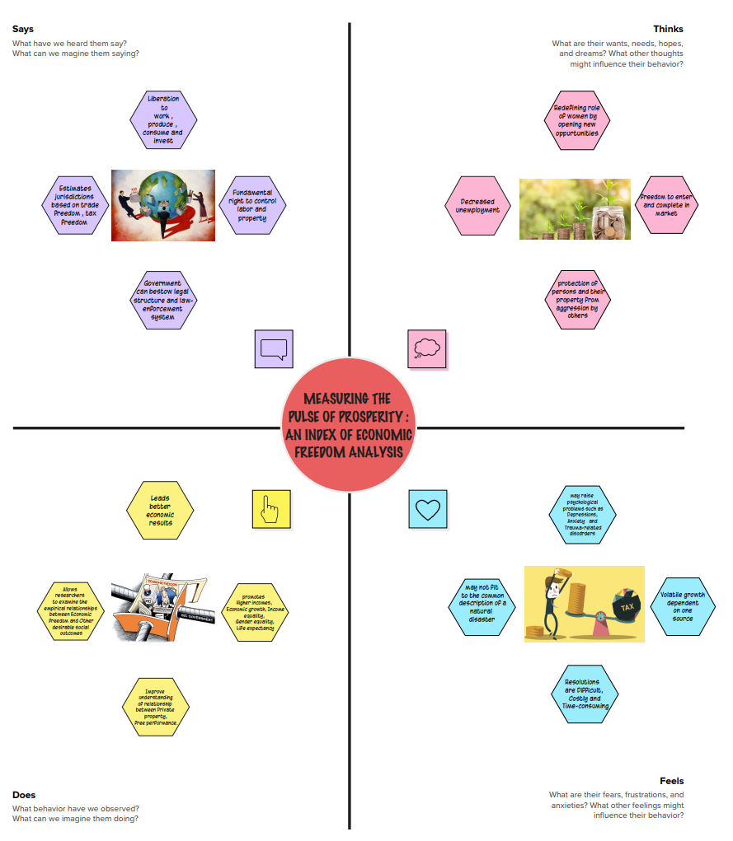

**2.2 IDEATION & DESIGN THINKING**

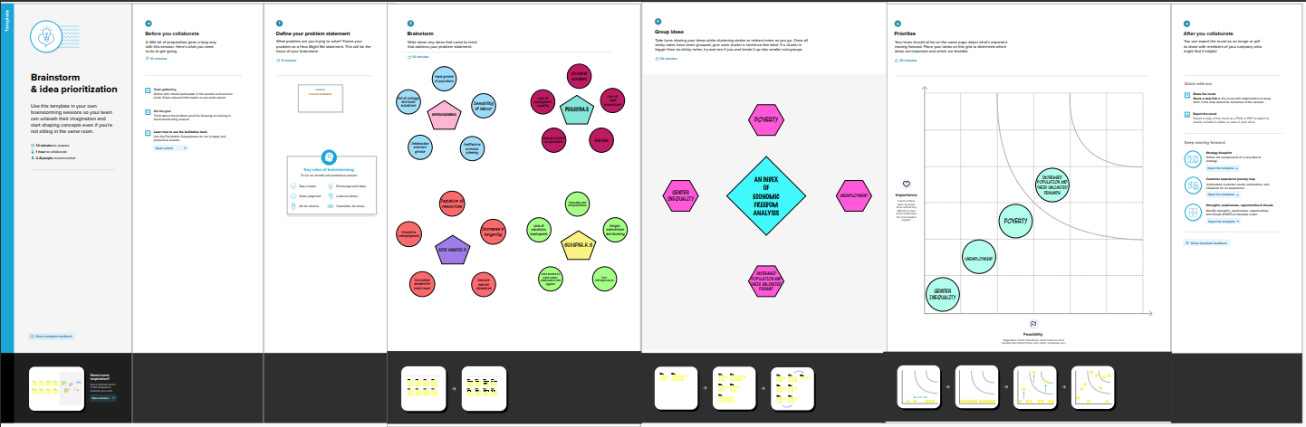

**3.RESULT**

**STORY**

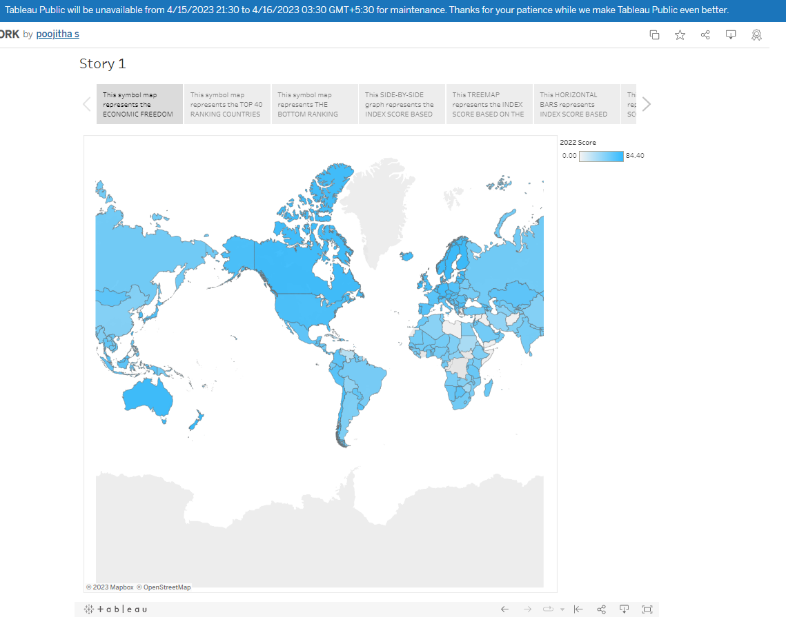

**DASHBOARD**

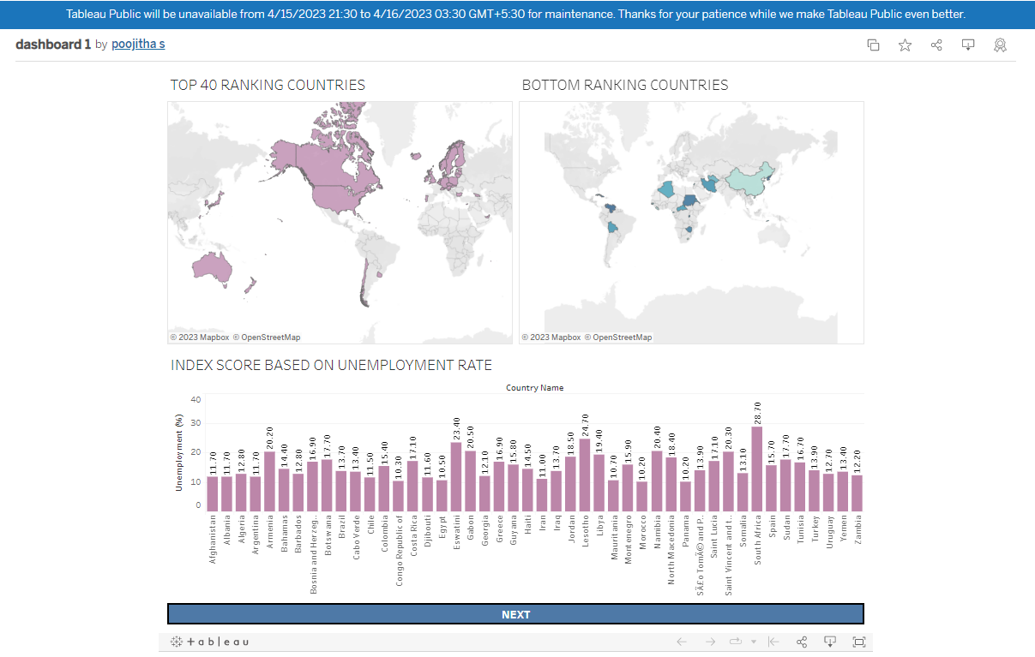

**4.ADVANTAGES & DISADVANTAGES**

**ADVANTAGES:**

1. Personal Choice

2. Voluntary Exchange Coordinated by Markets

3. Freedom to Enter and Compete in Markets

4.Protection of persons and their property from aggression by others

5. Nations with greater economic freedom have stronger economies, with higher gross domestic product per person.

6. Citizens in countries that are economically free enjoy twice as much formal education on average as those in economically repressed nations

7. Free trade is a key element of economic freedom. Countries that embrace free trade enjoy more prosperity as a result.

**DISADVANGAGES:**

1. Unemployment and Inequality.

2. Poor Quality

3. Excessive power of firms

4. Environmental Concerns

5. An increased barrier to entry

6. Limited product choices

7. Risk of market failure

8. Exploitation of consumers

**5.APPLICATION**

1. Economic freedom promotes participation and collaboration.

2. Here individuals are free to work, produce, consume, and invest in any way.

3. Economic freedom is extremely significant in preventing wars

4. Promotes in higher income

5. Reduces poverty

6. Improves better facilities

**6.CONCLUSION**

The index of economic freedom is one of several metrics for comparing different economic regimes. Although the Heritage Foundation publishes the most widely-used economic freedom index, there are several institutions that publish their own versions.

Each of them seeks to quantify elements such as regulation, taxation, government interference, and price controls, which represent constraints on free enterprise and market activity.

**7.FUTURE SCOPE**

1. May improve gender equality and employment.

2. May Increases liberty on their own business.

3. Improvement in accessing the goods.

4. May decrease higher crime rates.

5. May improve lower average education levels.

6. Seeks to understand and shape macro and microeconomic policies in order to lift poor countries out of poverty.

7. Services which are profitable.